**INSTALATION MANUAL**

1. Download and install Node.js

Node.js® is a free, open-source, cross-platform JavaScript runtime environment.

<https://nodejs.org/en/download>

Download LTS version with npm.

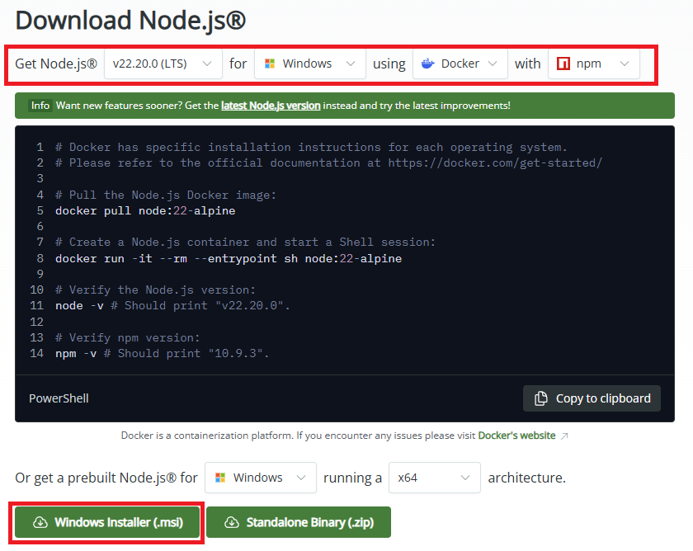

1. Unpack zip with app
2. Open the unpacked folder.
3. Run (double click) file setup.bat

This file will install all required dependencies.

**USING APP MANUAL**

1. Run (double click) file run-app.bat

Wait for the command line showing information “Ready in X.Xs”.

Don’t close the window.

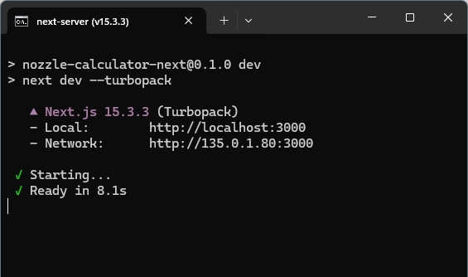

1. Open browser and enter address

<http://localhost:3000/>

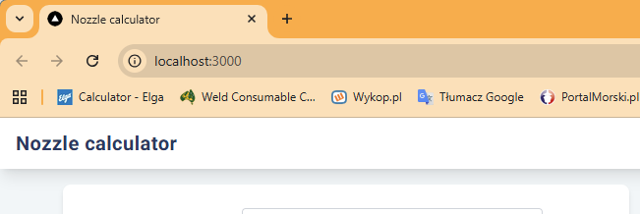

1. App will work as long as the Command Prompt window is open.